Software Design Specifications

**Online Domestic Services**

Project Code:

BS-313537

Internal Advisor:

Dr. Hafiz Faisal Shahzad

Project Manager:

Dr. Muhammad Ilyas

Project Team:

|  |  |  |  |
| --- | --- | --- | --- |
| **Sr. No** | **Name** | **Roll No** | **Role** |
| 1. | Aleena Nadeem | BSEF19M037 | Team Leader |
| 2. | Maria Zareef | BSEF19M031 | Team Member |
| 3. | Aqib Ijaz | BSEF19M035 | Team Member |

Submission Date:

22-12-2022

Project Manager’’s Signature

# Document Information

|  |  |
| --- | --- |
| **Category** | **Information** |
| Customer | CS & IT, UOS |
| Project | Online Domestic Services |
| Document | Software Design Specifications |
| Document Version | 1.0 |
| Identifier | BS-313537 |
| Status | Draft |
| Author(s) | Aleena Nadeem  Maria Zareef Aqib Ijaz |
| Approver(s) | Dr. Muhammad Ilyas |
| Issue Date | Dec 4, 2022 |
| Document Location | University of Sargodha |
| Distribution | 1. Advisor 2. PM 3. Project Office |

**Definition of Terms, Acronyms and Abbreviations**

|  |  |
| --- | --- |
| **Term** | **Description** |
| ASP | Active Server Pages |
| DD | Design Specification |
| OOD | Object-oriented design |
| DFD | Data Flow Diagram |
| GUI | Graphic User Interface |
|  |  |
|  |  |
|  |  |

# Table of Contents

1. Introduction 4
   1. Purpose of Document 4
   2. Project Overview… 4
   3. Scope 4
2. Design Considerations 4
   1. Assumption And Dependencies 4
   2. Risk And Volatile Areas 5
3. System Architecture 6
   1. System Level Architecture 7
   2. Sub-System/ Component / Module Level Architecture 8
   3. Sub-System/ Component / Module Level Architecture 11
4. Design Strategies 13
   1. Strategy 1…n 13
5. Detailed System Design 14
6. Reference 26

# Introduction

We are developing a platform, which will facilitate the customer to provide information about domestic services. Our platform will provide an easy way to find trusted helpers. A customer can simply complain and send feedback after login in.

## Purpose of Document

This Software Design Document provides a description of the system design to allow the development to proceed with an understanding of what we need to build and how it is expected. It will provide a detailed design description of the online home service system**.** The purpose of this document is to provide graphical documentation of the software design for the project including sequence diagrams, collaboration models, use case models, Data flow models, and other supporting requirement information. It will focus on the base-level system and critical parts of the online domestic system.

## Project Overview

We are developing software that will provide all basic household services at your fingertips. This app will be innovative and interesting as you can get all the benefits like search, accuracy, an appointment with a service provider, and sending payment from a single app. We will design an interactive user interface for searching services on the go.

* + - This app will provide details about the experience, performance, and rating of different service providers such as gym trainer’s carpenters, plumbers, electricians, and many more, which other applications are not providing.
    - This application will allow users to register as a person requiring service or a person providing a service.
    - This application will allow payment through online payment mode or cash on delivery mode.
    - Customer can give feedback to the service provider

## Scope

The scope of our project is to provide a safe and user-friendly environment for online service booking. A two- way communication platform between the service provider and the service receiver can eliminate the exhausting efforts of finding a suitable service provider. A feedback-based rating system can improve the skills of any service provider and the service recipient can ultimately get better services. The overall system can be designed for increasing its capacity in response to additional requests for which the application provides the corresponding service overseas. Furthermore, this application will extend only by adding up the required services and systems.

# Design Considerations

The design phase goal is to transform the requirements into a structure specified in the SRS document that is suitable for implementation in some programming languages. In technical, the software architecture is derived from the SRS document during the design phase.

## Assumptions and Dependencies

Assumptions for the system related to design are the following….

* + - The service system will be able to handle high volumes of customer traffic.
    - Resources will be available for the designing system; the best way is to avail free resources available on the internet including Code libraries, font graphics, and script.
    - We assume that the service system will provide customers with accurate order tracking information.
    - We assume that the service system will offer personalized service options, such as discounts and special offers.
    - We assume that the service system will provide a secure environment to customers.
    - It is assumed the availability of proper tools and technologies. Designers should be given proper skills to use advance and up-to-date tools and techniques in designing good user interface.
    - It is assumed proper time and budget is estimated for designing phase. Realistic planning and meeting schedule will be maintained by stakeholders to develop the interface
    - We assume that the service system will provide customer support in a timely manner.

## System dependencies:

Dependencies for the system related to design are the following:

**Database:** To store the user, service provider, services categories data, and other related records. **Web Server**: A web server is required to host the website and make it available over the internet. **User Interface**: A user interface is required for the customers to interact with the system.

**Payment Gateway**: A payment gateway is necessary to enable customers to make payments.

**Security**: To protect the system from malicious attacks, and to secure user information, security measures such as firewalls and encryption will be required.

**Application Programming Interface (API):** An API is required to enable communication between the system and other external systems.

**Analytics**: To generate insights and track the performance of the system, analytics tools are required.

**Customer Support**: To provide customer service, a customer support system should be in place. **Communication Platform:** To facilitate communication between customers and service providers. **Scheduling Service:** To manage the task request and service booking.

**Rating system:** To rate the quality of the services provided by service providers.

**Notifications system:** To send notifications to customers and service providers about task requests and service bookings.

**Internet connection:** System will run on internet so in order to use system internet will be required.

* 1. **Risks and Volatile Areas**

|  |  |  |  |  |  |
| --- | --- | --- | --- | --- | --- |
| **Components**  **Categories** | | **Performance** | **Support** | **Cost** | **Schedule** |
| **Catastrophic** | 1. | There is also a risk to data security. The data can be taken over if the system is implemented on a non-encrypted platform. | | Security failure results in increased costs and schedule delays that will affect overall system performance. | |

|  |  |  |  |  |  |
| --- | --- | --- | --- | --- | --- |
|  | 2. | If the system will fail to deliver, promised services or benefits.  Failure to meet the desired requirements and poor infrastructure of the system could be a risk. | No responsive and unsupportable | Significant financial shortages, budget overrun likely | Unachievable |
| **Critical** | 1. | If a system does not support a scripting language like PHP to store important user information in a database. | | There can be a technical problem or the system might not be set up to respond to the user's query.  Inadequate user satisfaction and budget overrun. | |
| 2. | If the system does not show appropriate results to users’ queries. | A minor delay in software modulation | Some financial shortages, possible budget overrun | Unachievable |
| **Marginal** | 1. | A significant risk exists the tools and technologies may replace by other new technologies resulting in design challenges. | |  | |
| 2. | If the stakeholders are not collaborating and conducting meetings then there is a risk of the project collapsing. | Responsive support | To some extent financial shortages, possible budget overrun | Realistic achievable |
| **Negligible** | 1. | If the system lacks the ability to comprehend the context of the conversation | | Results in minor cost and schedule affect with an expected value of 5k or less. | |
| 2. | Customers may be unable to understand the content language. | Easily supportable | Possible budget underrun | Early achievable |

# System Architecture

The decomposition of the online domestic service system is the following

1. **Admin module**
   1. Manage services
   2. Service categories details
   3. Manage Customer or service provider
   4. FAQS
   5. Bookings
2. **Service Provider module**
   1. Profile details
   2. Provide Service
   3. View booking/orders
   4. Check Payment details
3. **Customer module**
   1. Check Services categories
   2. Book a service
   3. Payment
   4. Feedback

The admin module will handle the user login to the application and database. Admin will assign access rights to a user, manipulate the data, and will manage all the transactions. He can verify the service provider/worker and customer, can manage all the categories of service, take the payment from the customer, and can send notifications to the customer and service provider.

This application will provide facilities to the customer such as registration, display profile of service provider, advertisement, check worker past rating or experience, user can select and request for service, different online payment methods and give feedback about worker performance, etc. However, service provider first register to system and then log in, create profile, provide services, check customer order, accept or reject service request and get payment.

## System-Level Architecture

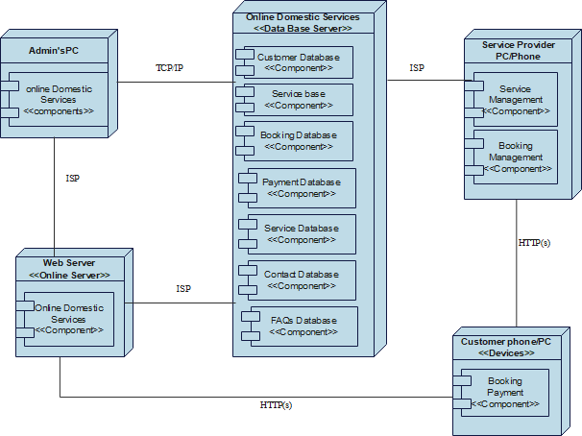

**Figure 1: Package and Deployment Diagram**

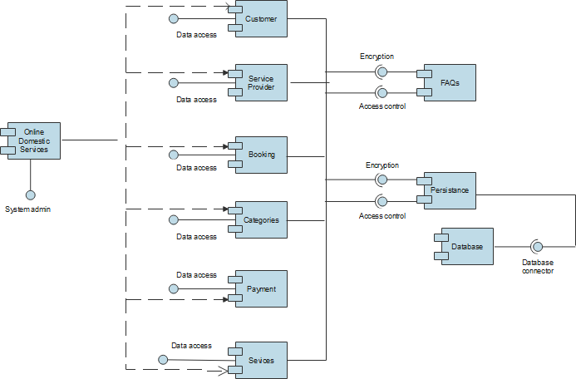

**Figure 2: Component Diagram**

## Sub-System / Component / Module Level Architecture

* + 1. **Sub-System Level Architecture:**

1. User Management System: This system provides the user interface for users to sign up, login, and manage their profiles.
2. Payment System: This system provides the payment gateway for users to make payments for their purchases.
3. Delivery System: This system provides the delivery services for users to receive their orders.

## Component Level Architecture:

1. User Interface: This component provides the user interface for users to interact with the system.
2. Database: This component provides the database to store user information and product information.
3. Payment Gateway: This component provides the payment gateway to process payments.

## Module Level Architecture:

1. User Management Module: This module provides user management functionalities such as sign up, login, and profile management.
2. Payment Module: This module provides payment functionalities such as payment gateway integration, payment

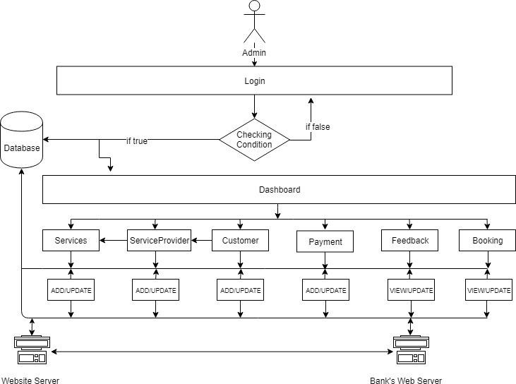

**Figure 2: Admin System Level Architecture Diagram**

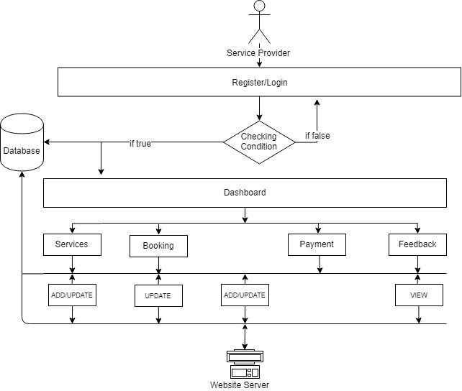

**Figure 2: Service Provider System Level Architecture Diagram**

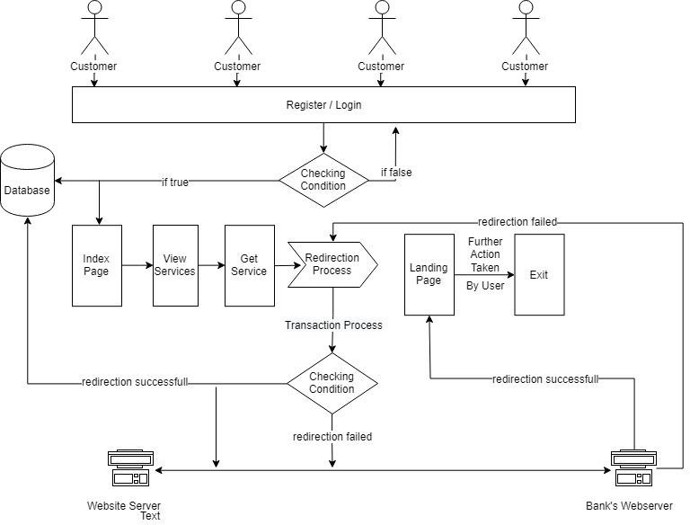

**Figure 3: Customer System Level Architecture Diagram**

## Sub-Component / Sub-Module Level Architecture (1n)

* + 1. **User Interface:**

This layer is responsible for providing a graphical user interface for users to interact with the system. It consists of web pages, HTML forms, text boxes, drop down menus, and navigation links.

## Business Logic Layer:

This layer contains code that makes decisions based on user input, fetches data from the database, and interacts with the presentation layer.

## Data Access Layer:

This layer is responsible for communicating with the database and providing data to the business logic layer. It consists of stored procedures, views, functions, and triggers.

## Database:

This layer contains the data that the system needs to operate. It can be a relational database or NoSQL database.

## Web Server:

This layer is responsible for hosting the web application and providing access to users. It can be a web server like Apache or IIS.

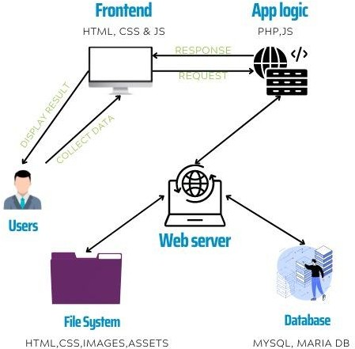

**Figure: Sub-Component / Sub-Module Level Architecture (1n) Diagram**

# Design Strategies:

The app is designed to provide an excellent user experience and an interactive user interface. It should also be easy to use, deliver some value to the user that they would not get from a conventional website, and integrate data together to enhance customer experiences. This application will specially design for household users who want services. We will focus to develop the app according to customer requirements and use the object oriented design approach. Design strategies include:

* 1. **Future system extension or enhancement:**

The application will be more interactive by giving users real-time control and by adding more animations. Adding more servers, and updating software versions. Implementing a reliable content delivery network (CDN), compressing data, encrypting all user private, sensitive data and using multi-factor authentication, and enabling browser caching (like images, videos, graphics, and audio content). The application is built only for android users and can be extended for other platforms like iOS etc. we can also add extra payment methods so that users can complete transactions at their convenience.

* 1. **System reuse**:

We can reuse pre-made templates, UI toolkits, open-source frameworks and libraries, graphic parts, and CSS animations, code-optimized CSS and JavaScript files, compressed images and videos, website speed testing tools, Bootstrap 5, and CSS frameworks.

* 1. **User interface paradigms**:

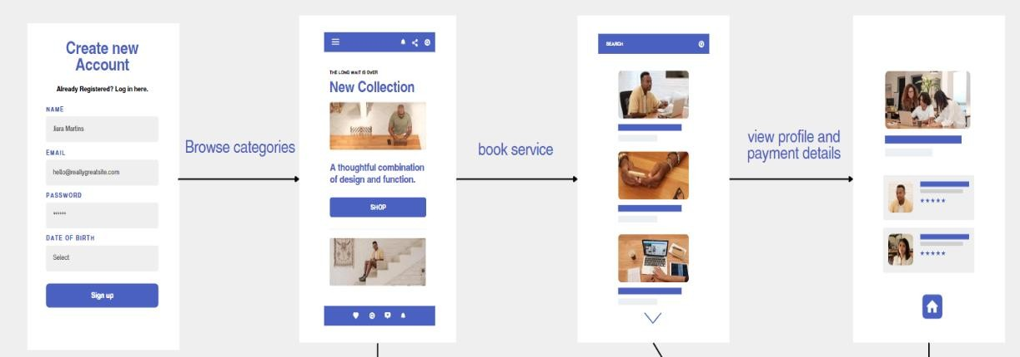

# Detailed System Design

A detailed design should include the following:

## DFD (0 Level/Context Level):

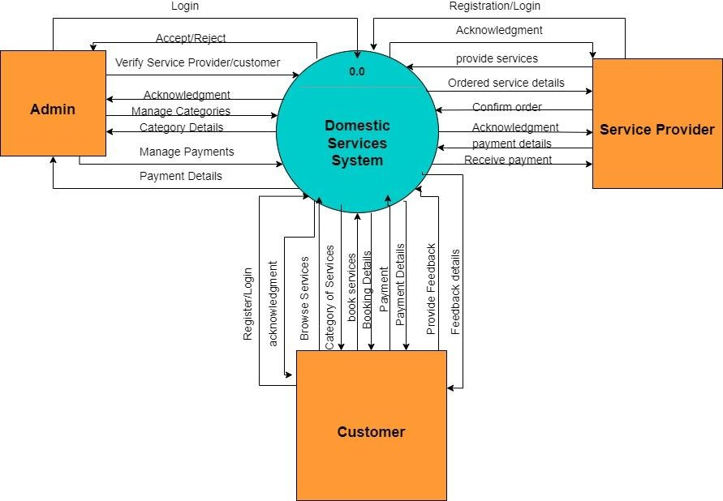

* 1. **DFD (Level 1)**:

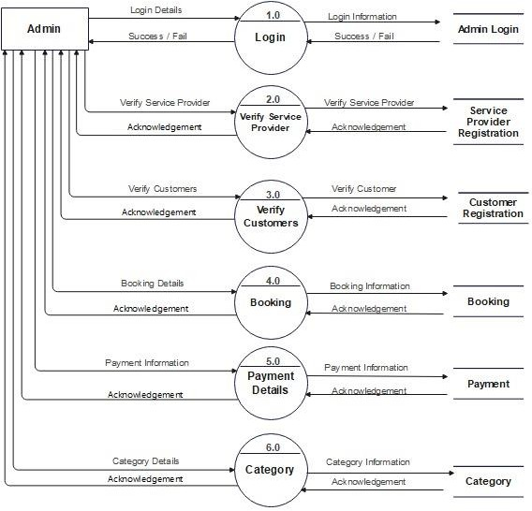

**Figure 3: Admin DFD Level 1 Diagram**

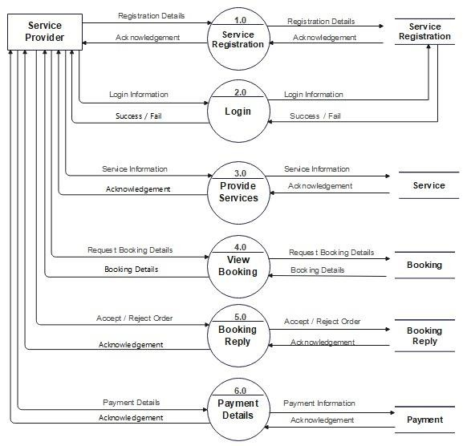

**Figure 2: Service Provider DFD Level 1 Diagram**

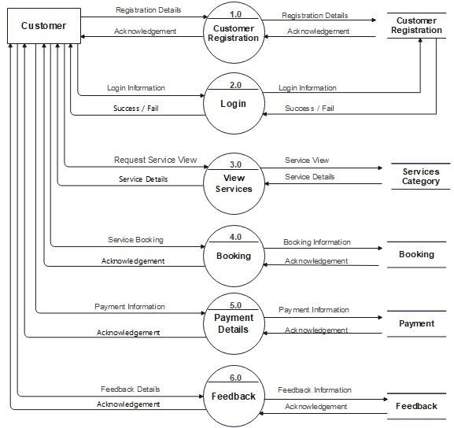

**Figure 3: Customer DFD Level 1 Diagram**

## Use Case Diagram

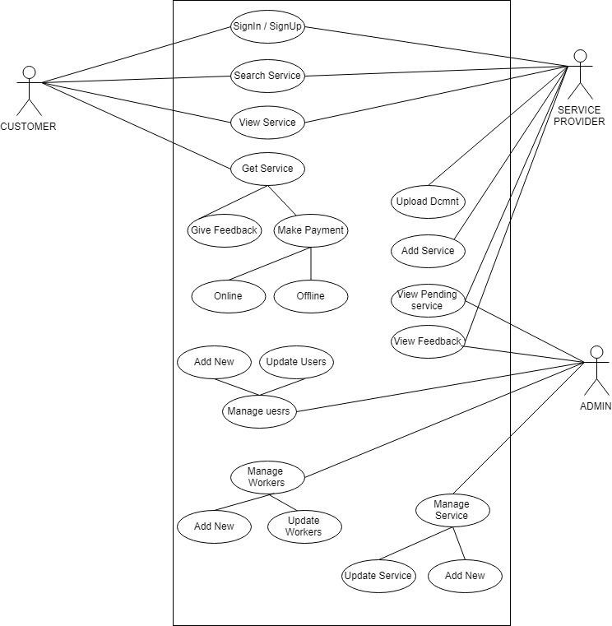

* 1. **Class diagram**

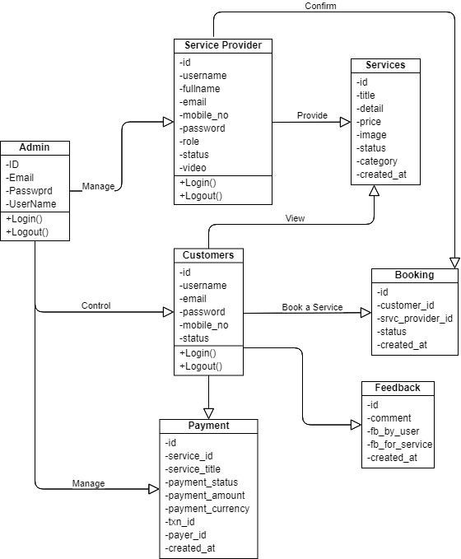

## Logical data model (E/R model)

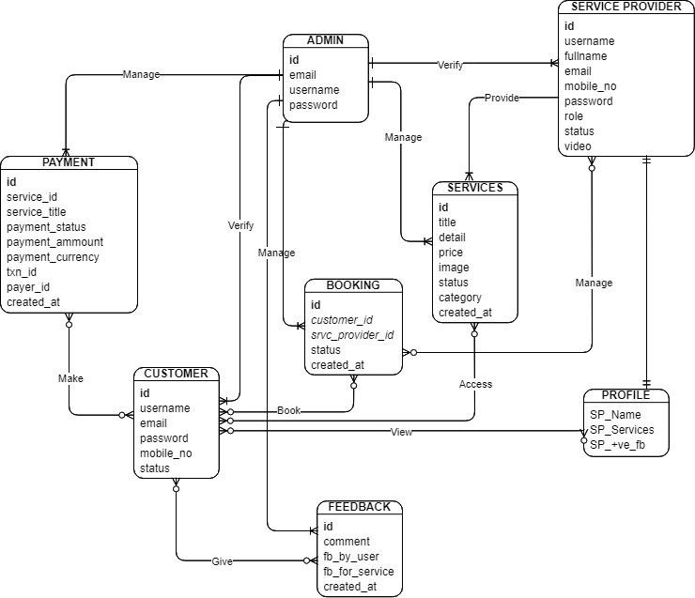

* 1. **State Transition Diagram**

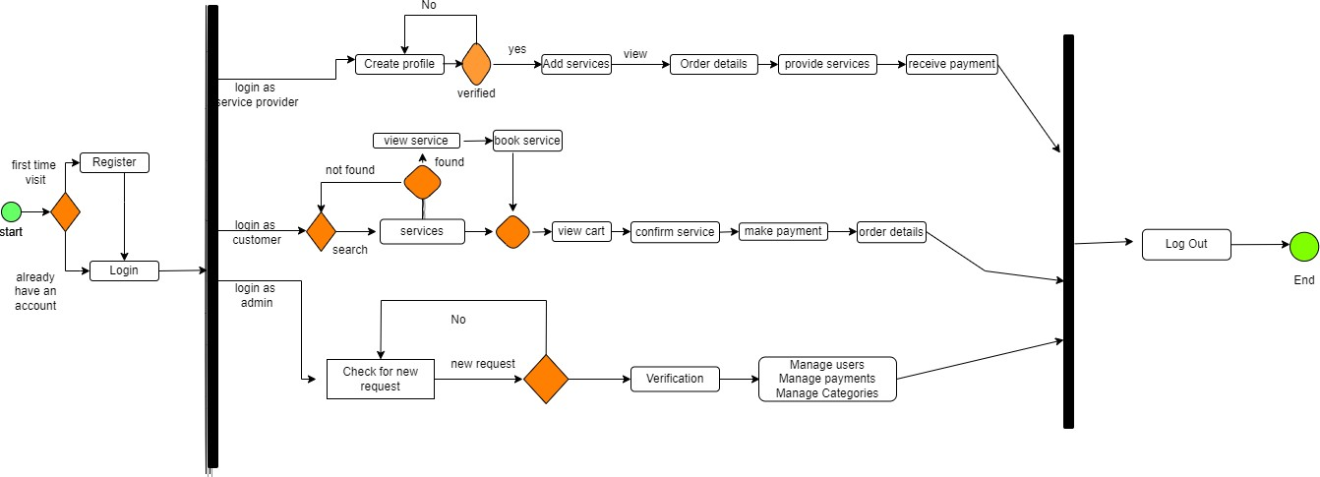

## Sequence Diagram: Admin:

**Customer:**

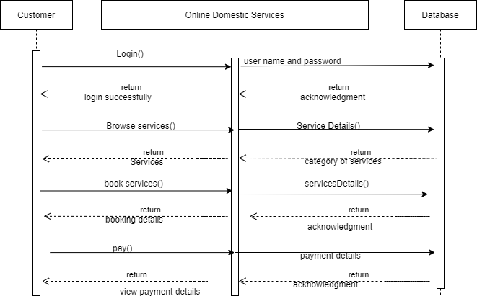

## Service Provider:

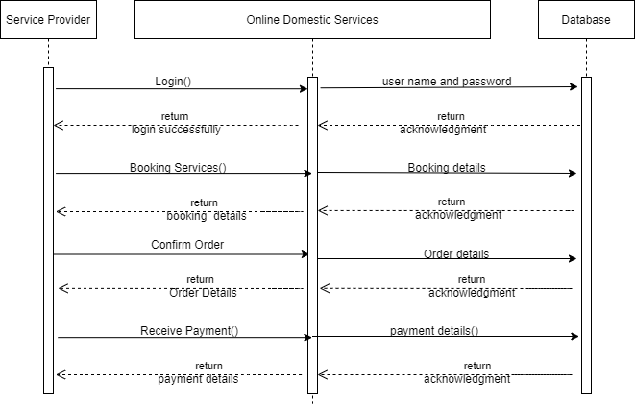

* 1. **Physical Data Model:**

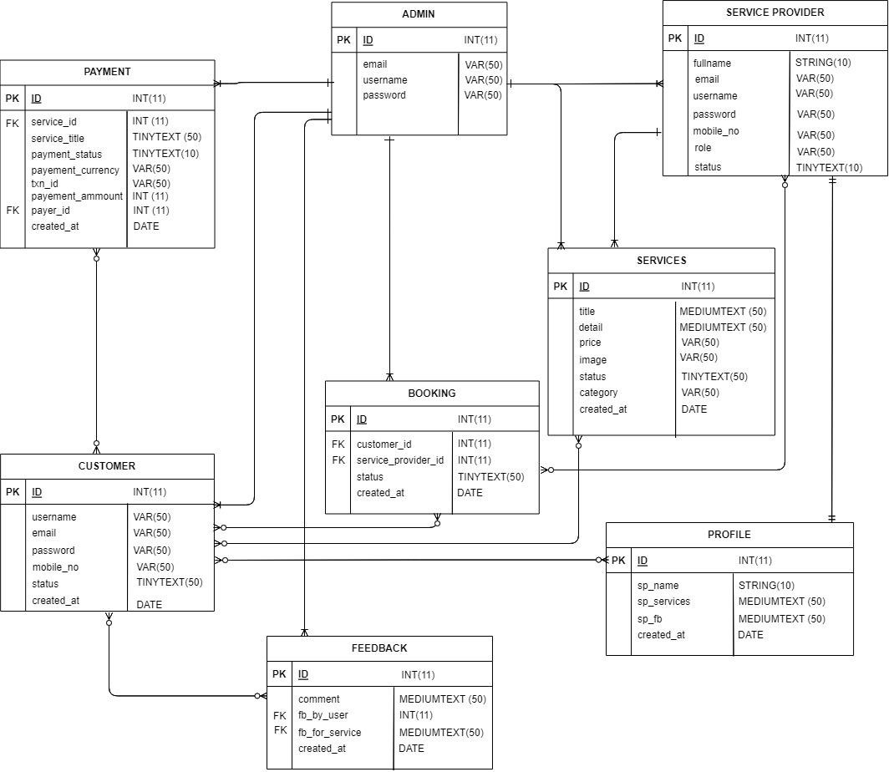

## GUIS: Android App Login page

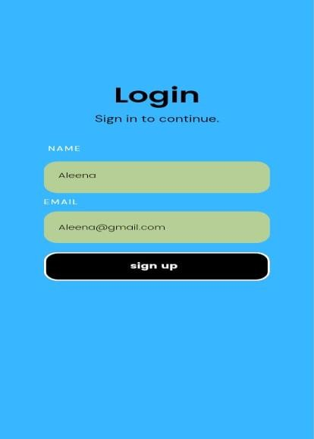

**Service Categories page:**

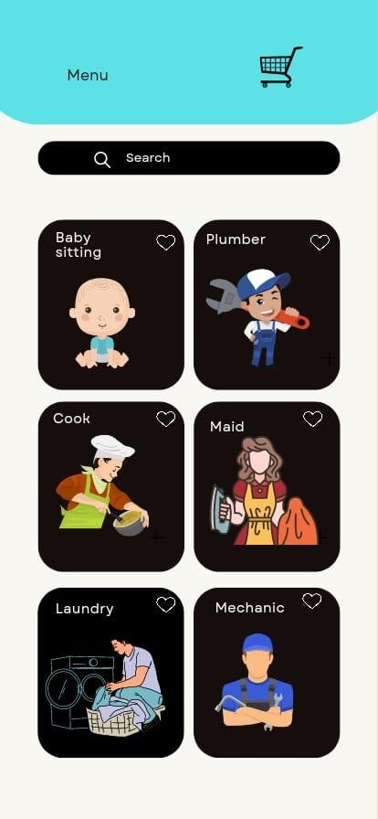

## Home Page of web application

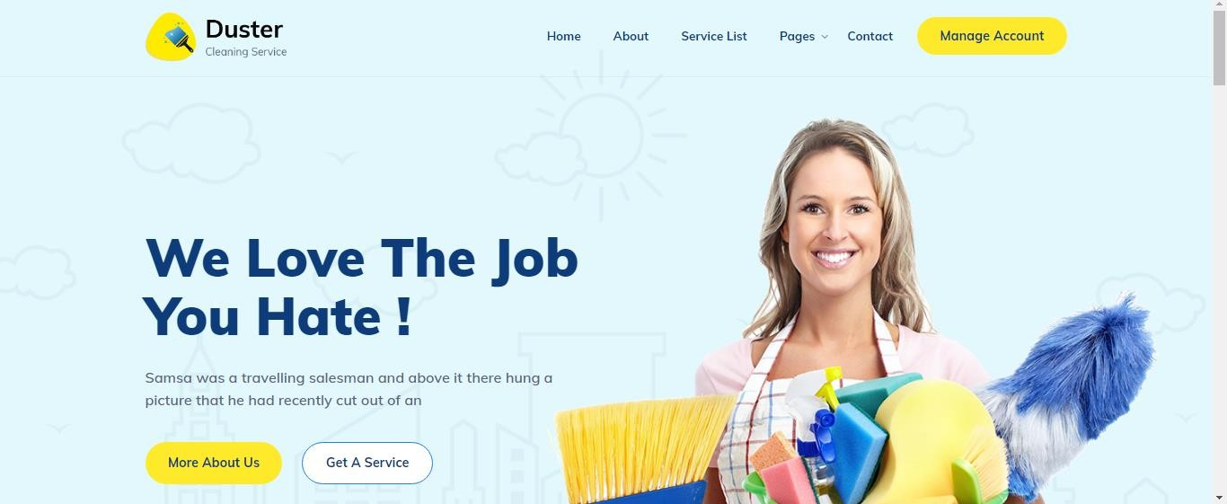

* **Contact Us Page**

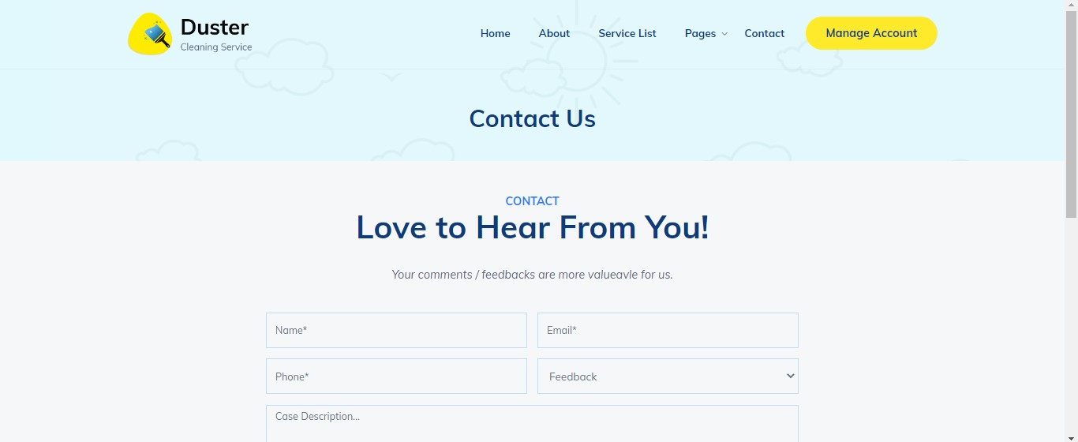

* **Our Services Page**

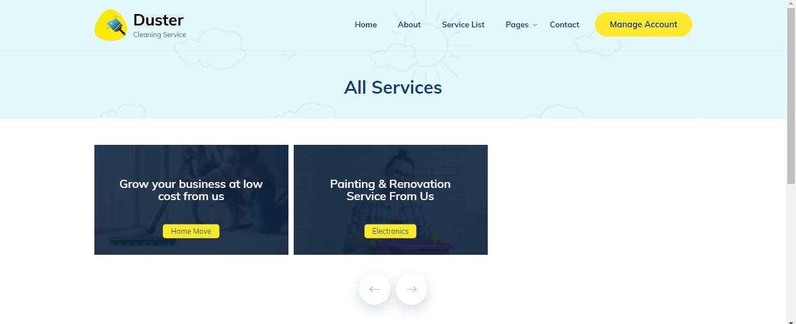

# References

1. Slaughter, E. S. (2001). Design strategies to increase building flexibility. *Building Research & Information*, *29*(3), 208-217.
2. Eden, A. H., & Kazman, R. (2003, May). Architecture, design, implementation. In *25th International Conference on Software Engineering, 2003. Proceedings.* (pp. 149-159). IEEE.Ahmand, W. (2018). Maid services. Retrieved from Maid in Pakistan: [https://www.maidinpakistan.com.pk](https://www.maidinpakistan.com.pk/)
3. Wang, X., Lu, X., Liu, B., Chen, D., Tong, Y., & Shen, G. (2014). Flexible energy‐storage devices: design consideration and recent progress. *Advanced materials*, *26*(28), 4763-4782.
4. Nykanen, E. (2015). Home service concept. Retrieved from Research Gate: https://[www.researchgate.net](http://www.researchgate.net/) 5.Asrar, S. (2021). 'Are we not human?'Pakistan Domestic workers confront abuse. Retrieved from CsMonitor:

https://[www.csmonitor.com/World/Asia-South-Central/2021/0830/Are-we-not-humans-Pakistan-s-](http://www.csmonitor.com/World/Asia-South-Central/2021/0830/Are-we-not-humans-Pakistan-s-)

domestic-workers-confront-abuse

1. Adarsh G2, N. M. (2018). An Online System for Household Services. Retrieved from INTERNATIONAL JOURNAL OF ENGINEERING RESEARCH & TECHNOLOGY (IJERT)
2. Blackett, A. (2012). The decent work for domestic workers convention and recommendation, 2011. American Journal of International Law, 106(4), 778-794.
3. George, J. F., Batra, D., Valacich, J. S., & Hoffer, J. A. (2007). *Object-oriented systems analysis and design* (pp. 289-294). Pearson Prentice Hall.
4. Sternberg, C. (2019). The Hidden Hand of Domestic Labor: Domestic Employers' Work Practices in Chicago, USA. Frontiers in Sociology, 4, 80.
5. Nancy G. Leveson, Safeware System Safety and Computers, A guide to preventing accidents and losses caused by technology, Addison-Wesley Publishing Company, Inc. America, 1995.
6. Slaughter, E. S. (2001). Design strategies to increase building flexibility. *Building Research & Information*, *29*(3), 208-217.

|  |  |  |  |
| --- | --- | --- | --- |
| **Ref. No.** | **Document Title** | **Date of Release/ Publication** | **Document Source** |
| BS- 313537 | Project Proposal | 18-10-2022 | <Give the path of your Project  repository/Folder> |
| BS- 313537 | Functional Specification | 15-11-2022 | <Give the path of your Project  repository/Folder> |
|  |  |  |  |
|  |  |  |  |
|  |  |  |  |
|  |  |  |  |
|  |  |  |  |
|  |  |  |  |
|  |  |  |  |